Data analytics project-1

Weather data set report

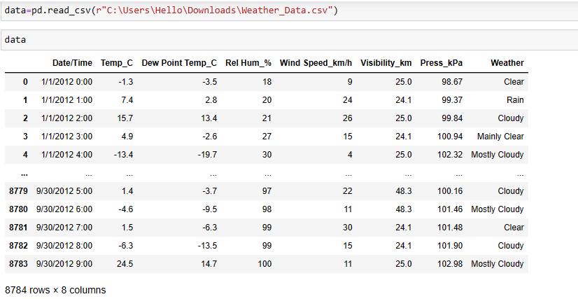

Hear it is a data set of weather by the data set we do some manipulation and find out meaning full insights and make a report so that is will be easy to understand for the client .

Q. 1) Find all the unique 'Wind Speed' values in the data.

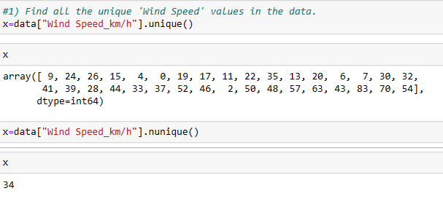

* Hear we do some manipulation on data to find the output.
* Hear to find the all unique “wind speed” values in data we can use the code data["Wind Speed_km/h"].unique(). Hear we use unique () function to find the unique value from them. We use x as a variable to store the data. by this code we know the unique values. We also use another code that is

data["Wind Speed_km/h"].nunique(). Hear we use nunique() function to find out the number of unique elements presents in a data.

Q. 2) Find the number of times when the 'Weather is exactly Clear'. 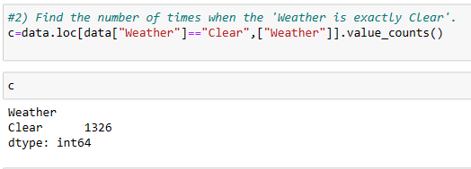

-> Hear we do some manipulation on data to find the output. Hear we use the code c=data.loc [data ["Weather"]=="Clear",["Weather"]].value_counts() to find the number of times when the 'Weather is exactly Clear'. We use the value_ counts () function to find out the number of times when the weather is clear from weather column. We use x as a variable to store a data.

Q. 3) Find the number of times when the 'Wind Speed was exactly 4 km/h'.

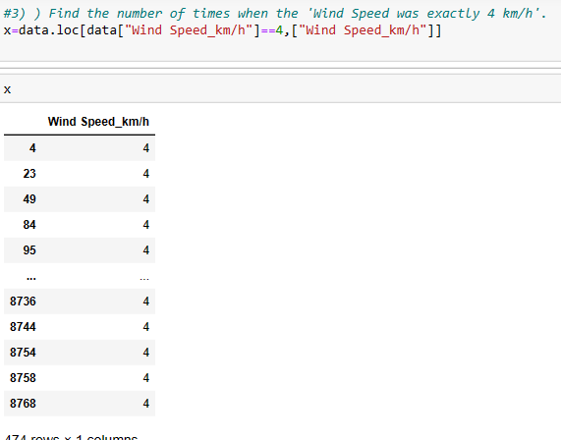

* Hear we do some manipulation on data to find the output. Hear we use the code x=data.loc [data ["Wind Speed_km/h"]==4,["Wind Speed_km/h"]] by the code we find the number of times when the 'Wind Speed was exactly 4 km/h' from the “ wind speed_ km/h” column. Hear we use x as a variable to store the data.

Q. 4) Find out all the Null Values in the data.

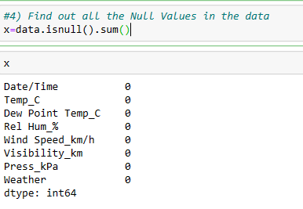

* Hear we do some manipulation on data to find the output. Hear We use the code is x=data.isnull().sum() by the manipulation we get all the Null values which is present in a data. We use sum () to find out the total number of null values which is present in a data. Hear we take x as a variable to store the above data.

Q. 5) Rename the column name 'Weather' of the dataframe to 'Weather Condition'.

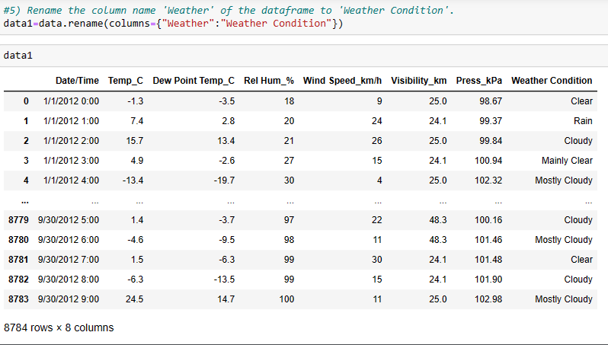

* Hear we change the column name of “weather” into “weather condition”, hhear we use the data1=data.rename(columns={"Weather":"Weather Condition"}) code to change the name of weather column of dataset. We use the rename () function to change the column name, we use data1 as variable to store the data.

Q. 6) What is the mean 'Visibility' ?

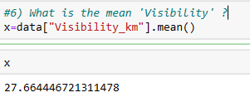

* Hear we use the x=data["Visibility_km"].mean() code to find out the mean value of “visibility_km” column of dataset.hear we use mean() function to find out the mean value of the column. We use x as a variable to store the output of above code.

Q. 7) What is the Standard Deviation of 'Pressure' in this data?

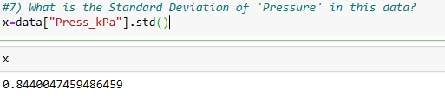

* Hear we use the x=data["Press_kPa"].std() code to find out the Standard Deviation “press_kpa”of column of dataset .hear we use std() function to measuring the dispersion of each value of the column. We use x as a variable to store the output of above code.

Q. 8) What is the Variance of 'Relative Humidity' in this data?

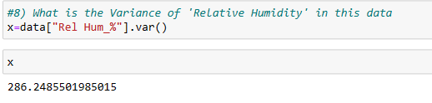

* Hear we use the x=data["Rel Hum_%"].var() code to find out the Variance of “Rel Hum_%” column of dataset .hear we use Var() function to estimation of how broadly the values in a data sets are different from the mean value. we use the var() to find the value which is different from the mean value. We use x as a variable to store the output of above code.

Q. 9) Find all instances when 'Snow' was recorded.

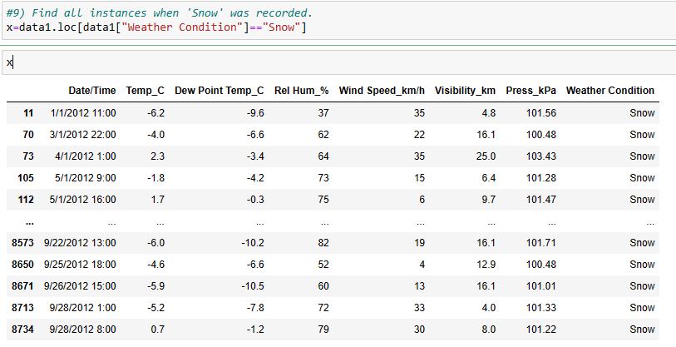

* Hear we use the x=data1.loc[data1["Weather Condition"]=="Snow"] code to find the all instances values when “snow “ was recorded. By the code we get all snow record from the “weather condition” column of the data set. we use x as a variable to store the output of the above code.

Q. 10) Find all instances when 'Wind Speed is above 24' and 'Visibility is 25'.

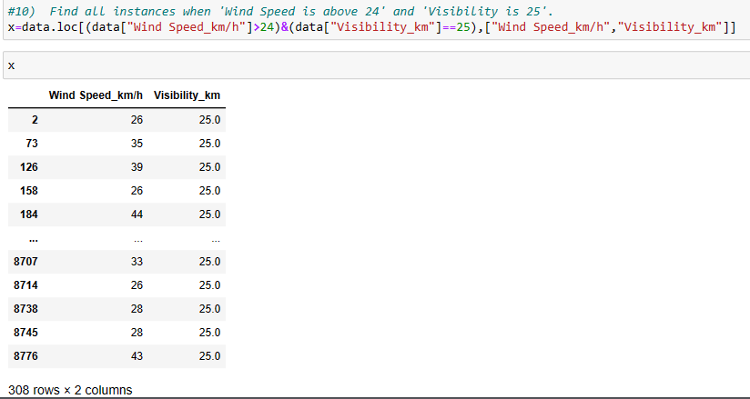

* Hear we use the code to find the value of given questions. We use the x=data.loc[(data["Wind Speed_km/h"]>24)&(data["Visibility_km"]==25),["Wind Speed_km/h","Visibility_km"]] code to find instance values when “wind speed is above 24” and “visibility is 25 from the “wind speed_km/h” and “visibility_km” column of the dataset.we use x as a variable to store the values.

Q. 11) What is the Mean value of each column against each 'Weather Condition ?

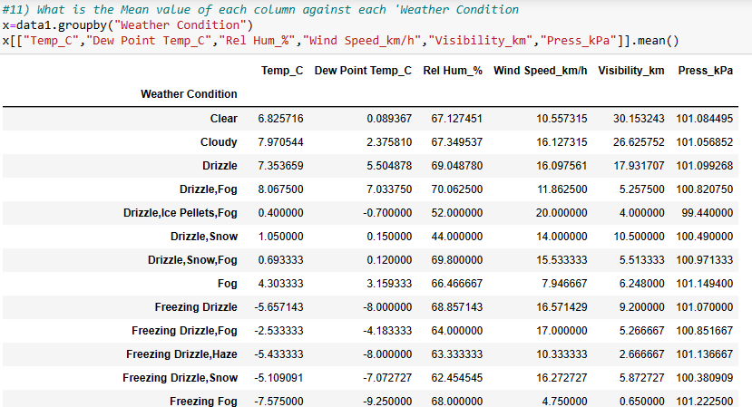

* Hear we do some manipulation to find the value from the above questions we use the x=data1.groupby("Weather Condition")

x[["Temp_C","Dew Point Temp_C","Rel Hum_%","Wind Speed_km/h","Visibility_km","Press_kPa"]].mean() code to find the mean values of each column against each of “ weather condition”. Here we use groupby() function to grouping the data points based on the distinct values from the “weather condition “ column. So that we get all mean values of the column which is related to the weather condition at a time. We use the x as a variable to store the information of above function.

Q. 12) What is the Minimum & Maximum value of each column against each 'Weather Condition ?

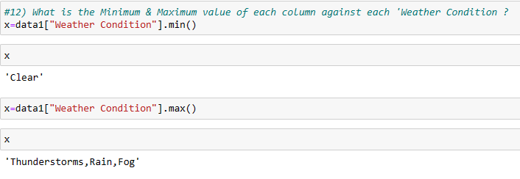

* Hear we do some manipulation on data to find the values of above questions . we use the code is x=data1["Weather Condition"].min() to find the minimum value from the “weather condition” column using min() function and we also apply the code is is x=data1["Weather Condition"].max() to find the maximum value from the “weather condition” column using max() function. We also use x as a variable to store the data.

Q. 13) Show all the Records where Weather Condition is Fog.

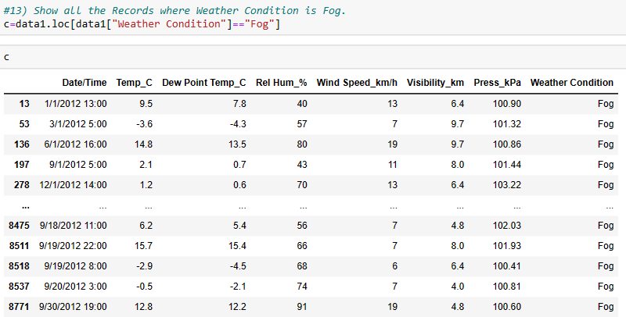

* Hear we do some manipulation to find all the records where weather condition is Fog. So that we use the c=data1.loc[data1["Weather Condition"]=="Fog"] code to find the value from the “ weather condition” column. Hear we use the loc operator to find the index a portion of the data Frame. We use c as a variable to store the value .

Q. 14) Find all instances when 'Weather is Clear' or 'Visibility is above 40'.

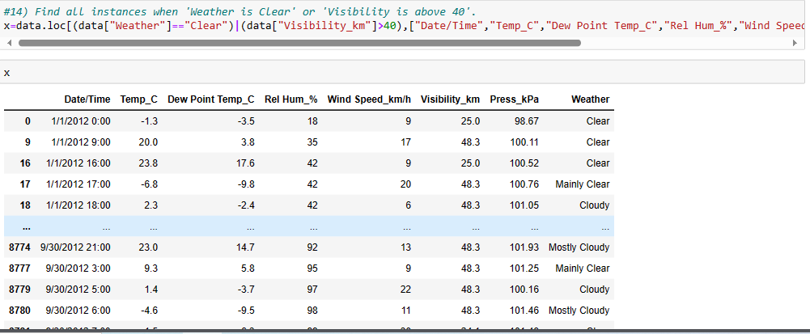

* Hear we use the code to find the value of given questions. We use the x=data.loc[(data["Weather"]=="Clear")|(data["Visibility_km"]>40),["Date/Time","Temp_C","Dew Point Temp_C","Rel Hum_%","Wind Speed_km/h","Visibility_km","Press_kPa","Weather"]] code to find instance values when “Weather is Clear' or 'Visibility” from the all coumns which is present I the data set.we use x as a variable to store the values.

Q. 15) Find all instances when :

A. 'Weat

her is Clear' and 'Relative Humidity is greater than 50'

or

B. 'Visibility is above 40'

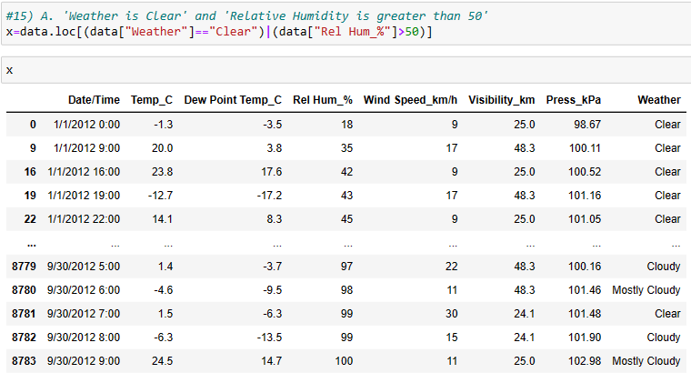

* Hear we use the code to find the value of given questions. We use the x=data.loc[(data["Weather"]=="Clear")|(data["Rel Hum_%"]>50)] code to find values when “wind speed is clear” and “Relative Humidity is greater than 50”from the “weather” and “Rel Hum_%” column of the dataset. We use x as a variable to store the values.

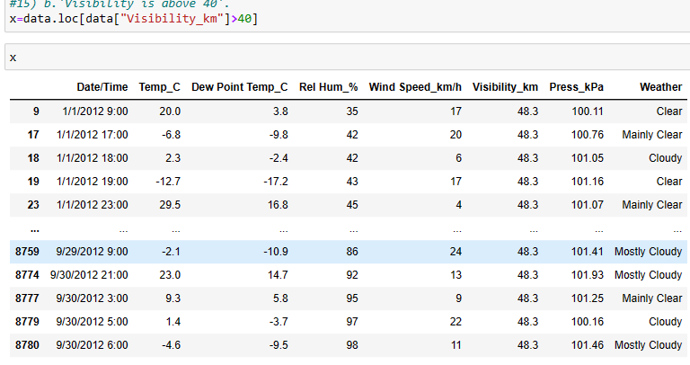

* Hear we use the code to find the value of given questions. We use the x=data.loc[data["Visibility_km"]>40]code to find values when “visibility is above 40”from the “Visbility_km” column of the dataset. We use x as a variable to store the values.

Hear we made a report on weather dataset which is having all important information about the data set which is help to understand for Clint.